Mir-142 predicted targets expression in lymphoma patients

Background:

* + Earlier Mir-142 Pancancer analysis identified hundreds of potential targets
    - **964** genes identified though significant correlation with miR-142, evidence of binding (AGO-Clip) or both
    - **959** had both RNA-Seq and CNA data and were used in this analysis by KI
  + 17 lymphoma patients had a mutation in miR142
    - Moved 6 AID patients out of these 17 to the control group, 11 patients with mutation remained as cases
  + Initial analysis showed that out of those predicted targets (n = 964), **235** were differentially expressed (using Wilcoxon test) between mutated and non-mutated samples (FDR adjusted)
* In this analysis, we found that these associations were due to the presence of additional subtypes
  + Only one lymphoma subtype actually had the mutation while the other subtypes did not and added additional expression values making the expression of the non-mutated group significantly higher or lower than the non-mutated group
* Identified this through two different models:
  + Linear Regression model using logged expression values
  + Negative Binomial Regression model using rounded expression values (flooring)

Results:

Lymphoma patients that I worked with:

* 208 in the PCAWG clinical file
  + 172 had both CNA and RNA-Seq data and were used for all my analysis
    - 102 Mature B-cell lymphoma
    - 68 Chronic lymphocytic leukemia
    - 2 lymphoma, NOS
* All 11 patients with Mir-142 mutation are from the Mature B-cell lymphoma subtype

Analysis:

1. Using all 172 patients covering the three different subtypes where subtype was added as a cofactor in the model
   1. lm(Target gene expression ~ mutation_status)
   2. lm(Target gene expression ~ mutation_status + target gene CNA)
   3. lm(Target gene expression ~ mutation_status + lymphoma subtype)
   4. lm(Target gene expression ~ mutation_status + target gene CAN + lymphoma subtype )
2. Using only the 102 Mature B cell lymphoma patients as patients with mutations are only found within this subtype
   1. lm(Target gene expression ~ mutation_status)
   2. lm(Target gene expression ~ mutation_status + target gene CNA)

Results:

1. **n = 172 patients, 959 genes tested**
   1. Linear Regression using logged expression values
      1. Results (FDR adjusted, p < 0.05):
         1. miRNA mutation as only predictor
            1. n = 222 genes associated with mutation presence (117 common)
         2. miRNA mutation and CNA of target gene as predictors
            1. n = 227 genes associated with mutation presence (126 common)
         3. miRNA mutation and lymphoma subtype as predictors
            1. n = 0 genes associated with mutation presence
         4. miRNA mutation, CNA and lymphoma subtype as predictors
            1. n = 0 genes associated with mutation presence
   2. Negative Binomial Regression using rounded expression values
      1. Results (FDR adjusted, p < 0.05):
         1. miRNA mutation as only predictor
            1. n = 161 genes associated with mutation presence (117 common)
         2. miRNA mutation and CNA of target gene as predictors
            1. n = 170 genes associated with mutation presence (126 common)
         3. miRNA mutation and lymphoma subtype as predictors
            1. n = 5 genes associated with mutation presence
         4. miRNA mutation, CNA and lymphoma subtype as predictors
            1. n = 2 genes associated with mutation presence
2. **n = 102 Mature B-cell lymphoma patients, 959 genes tested**
   1. Linear Regression using logged expression values
      1. Results (FDR adjusted, p < 0.05):
         1. miRNA mutation as only predictor
            1. n = 0 genes associated with mutation presence
         2. miRNA mutation and CNA of target gene as predictors
            1. n = 0 genes associated with mutation presence
   2. Negative Binomial Regression using rounded expression values
      1. Results (FDR adjusted, p < 0.05):
         1. miRNA mutation as only predictor
            1. n = 4 genes associated with mutation presence
         2. miRNA mutation and CNA of target gene as predictors
            1. n = 0 genes associated with mutation presence

Examples of differences in Wilcoxon test between testing all patients and just Mature B-cell lymphoma

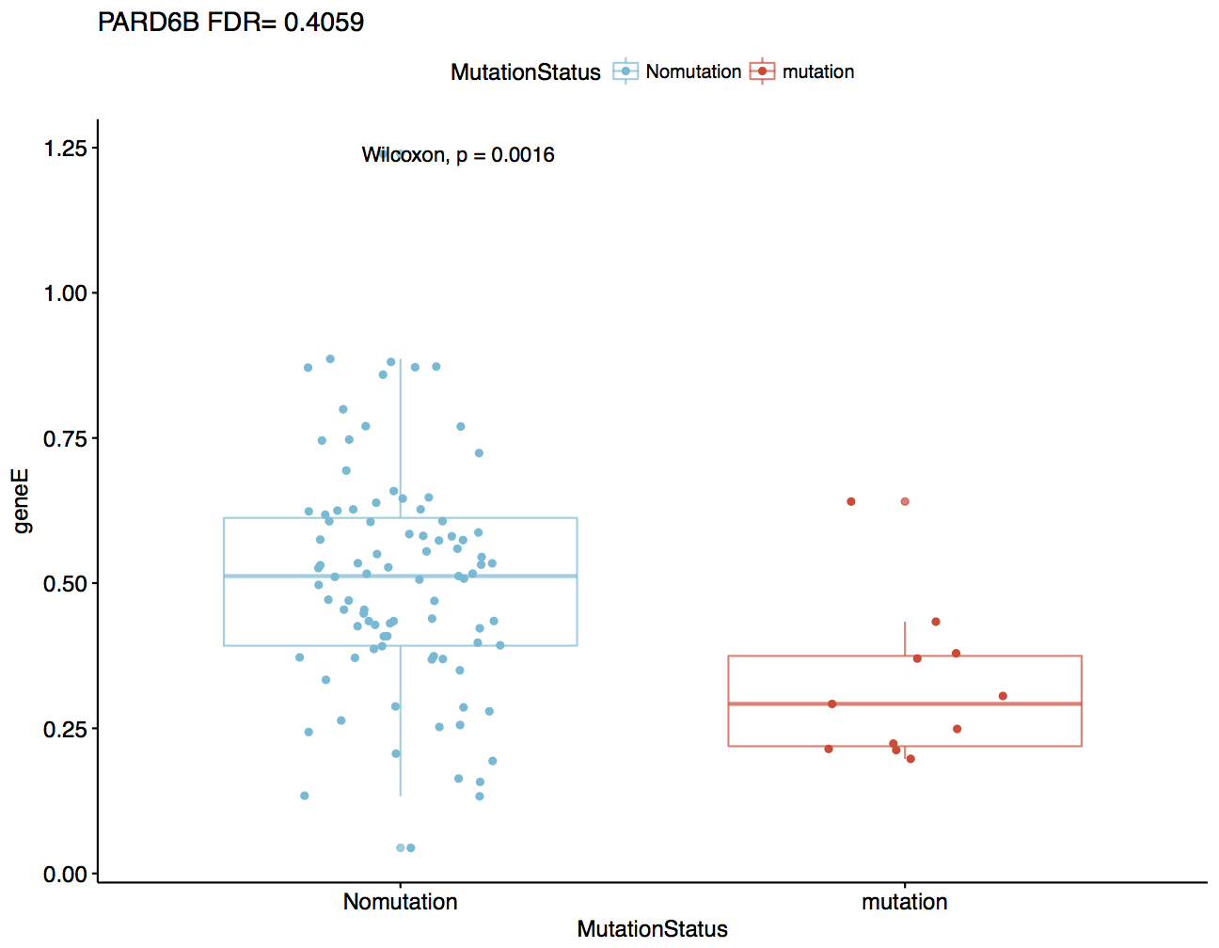

N = 102 Patients, Mature B cell lymphoma

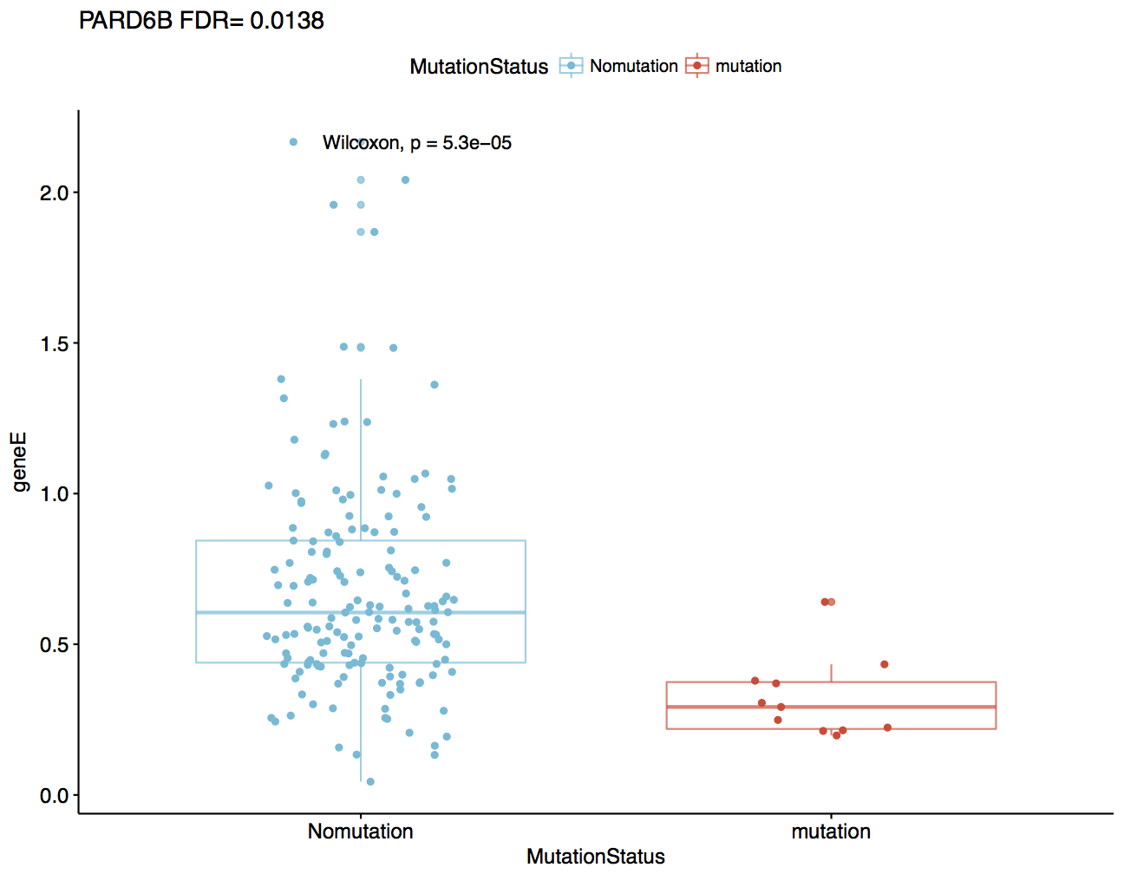

N = 172 Patients, all subtypes



N = 172 Patients, all subtypes



N = 102 Patients, Mature B cell lymphoma